4/8/2020

By Tyler Jaquish

Decision Tech Website Audit

(http://decision-tech.com)

Contents

Home Page – (decision-tech.com) - Desktop 2

Home Page – (decision-tech.com) – Mobile 3

Company Profile & Mission – (/company-profile-mission) – Desktop 4

Company Profile & Mission – (/company-profile-mission) – Mobile 5

Leadership – (/mk_team_page/leadership) – Desktop 5

Community Outreach & Sponsorships – (/mk_category/community-outreach-and-sponsorships) - Mobile 5

Contract Vehicles – (/mk_cat_flex/contract-vehicles) – Desktop 6

Seaport-e – (/mk_taskorders_page/task-orders-seaport-e) – Mobile 6

What We Do – (/mk_category/what-we-do) – Mobile 7

Why Decision Tech - (/mk_category/why-decision-tech) – Mobile 7

What We Help Accomplish – (/mk_category/what-we-help-accomplish) – Mobile 7

Job Seekers – (/job-seekers) – Mobile 7

404 Error Page – (any bad link) – Desktop 8

Contact Us – (/contact-us) - Desktop 8

Contact Us – (/contact-us) - Mobile 8

Join Our Team – (/join-our-team) – Desktop 9

Terms of Use – (/terms-of-use) – Desktop 9

Privacy Policy – (/privacy-policy) – Desktop 9

# Home Page – (decision-tech.com) - Desktop

* Problem: Hovering over each of the “What We Do” icons generates a request to reload the icon image, resulting in extra data transferred for no purpose



* Problem: Banner for “Why Decision Tech” is not centered
  + Everything else on the page seems to be centered, or centered with another element.



* Problem: “When Results Matter” down arrow icon actually refreshes page, taking user to the top.



* Problem: Footer “Contact” link redirects to top of page.
  + Also, Address and Phone number have inconsistent hover properties where they change color and cursor changes to “select text”. I suggest removing that for the address, and making the phone be a link to call (similar to header).

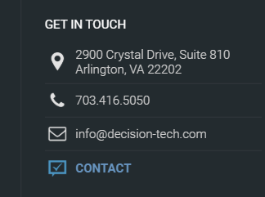

# Home Page – (decision-tech.com) – Mobile

* Problem: Logo size is not fully responsive. The hamburger menu gets pushed to the next line on smallest screens such as iPhone 5 and Galaxy S5.



* Problem: navigation is poorly designed for mid-size screens (tablets or landscape-oriented phones).
  + For this size screen, the navigation should use the hamburger menu for two reasons: Logo size should be significant and mobile devices have no hover, so the “Who We Are” dropdown has no effect.

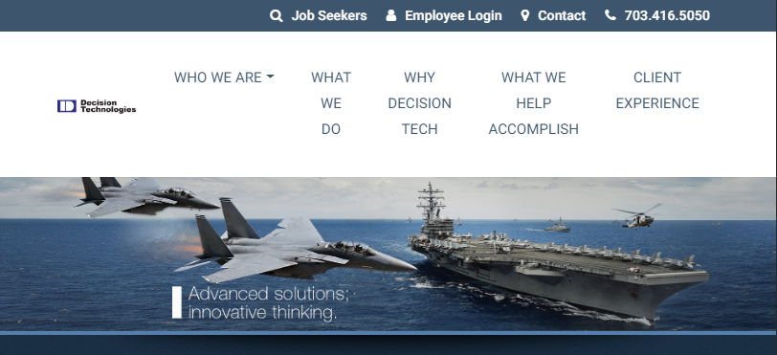

* Problem: “What We Do” icons have a side margin light blue color, except for “Program Management Support”

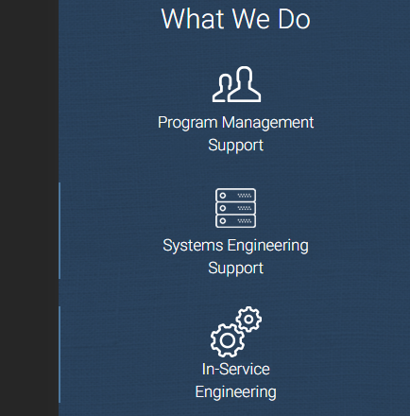

* Problem: The footer spacing and location for company logo breaks up the navigation items.
  + The Decision Technologies logo should be moved to a different part of the footer so that links flow smoothly.

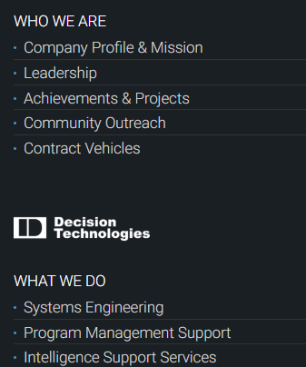

# Company Profile & Mission – (/company-profile-mission) – Desktop

* Problem: “Request a Call” form allows non-numbers as valid phone number

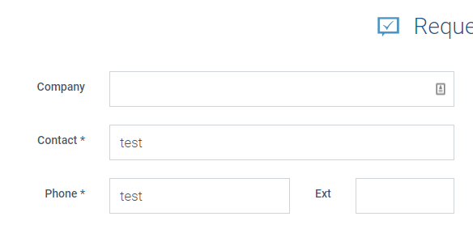

* Problem: Hovering on “Who We Are” icons reloads the icon image, causing extra data to be transferred, and most of the icons fail to load (notated in red).

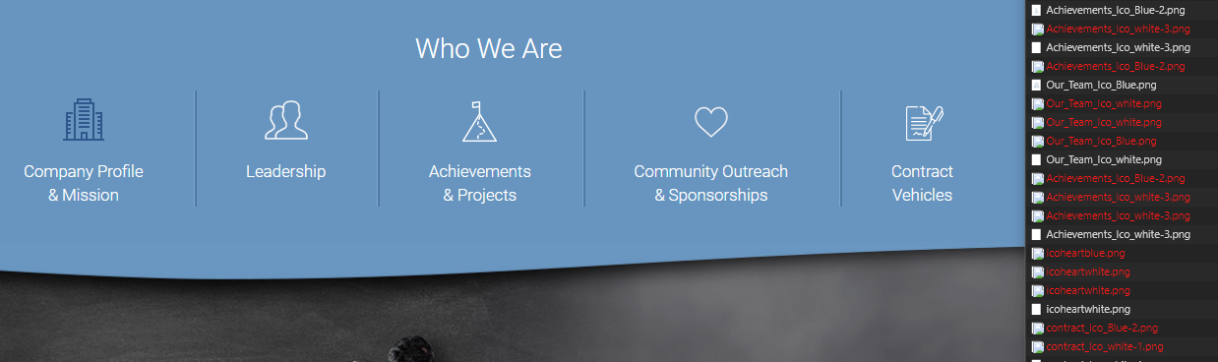

# Company Profile & Mission – (/company-profile-mission) – Mobile

* Problem: Submit button should be at the bottom of the form

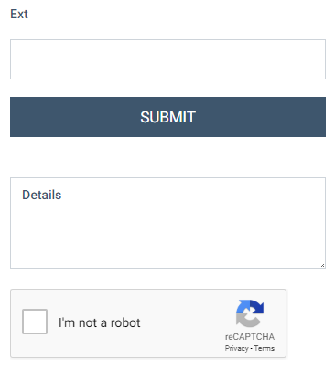

# Leadership – (/mk_team_page/leadership) – Desktop

* Not necessarily a problem, but observation: All of the email links to contact each person is to [info@decision-tech.com](mailto:info@decision-tech.com) except Nammy, which lists her individual email. I’m not sure if this was intentional.

# Community Outreach & Sponsorships – (/mk_category/community-outreach-and-sponsorships) - Mobile

* Problem: There is inconsistent margin for each of the sections, and the “Holiday Giving” and “Cinderella Ball” sections have no margin.



# Contract Vehicles – (/mk_cat_flex/contract-vehicles) – Desktop

* Problem: Link to “More Details” for Seaport-e loads page for Task Orders and Team Capabilities. On the “Team Capabilities” tab, Michael Harmon is listed as “Chief of Staff”, should be “Director of Operations”.
* Problem: Link to “More Details” for Seaport Next Generation loads an empty page for Task Orders.

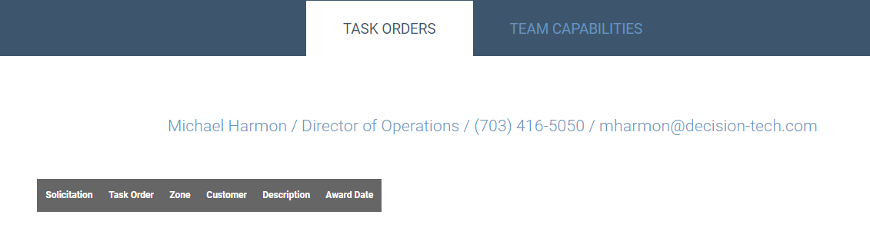

* For all the companies listed on Team Capabilities, is there a reason for them to link and be listed twice on the page, for what appears to be no reason?

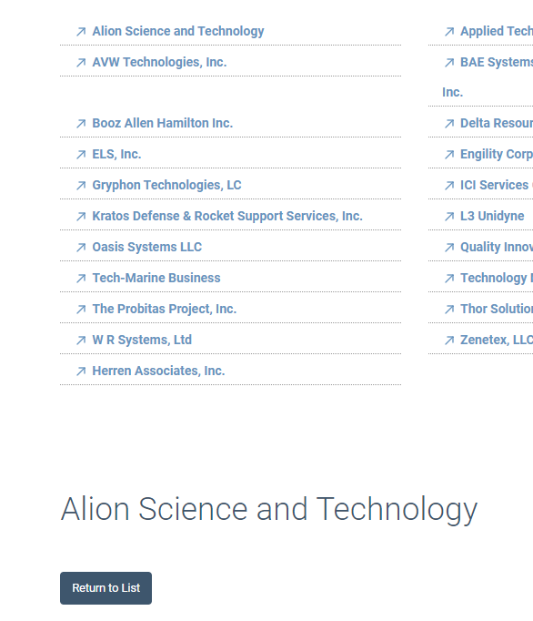

# Seaport-e – (/mk_taskorders_page/task-orders-seaport-e) – Mobile

* Problem: The “Task Orders” table expands to side scroll, making navigation hidden from user. I think the best solution would be to pivot the table to be vertical on mobile so that all elements fit on screen without side scroll.

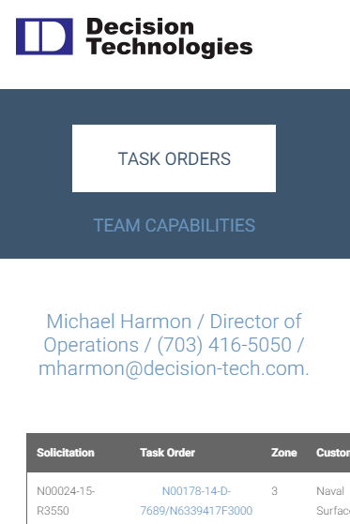

# What We Do – (/mk_category/what-we-do) – Mobile

* Problem: Left and Right margin is inconsistent throughout the page. There is a white strip of padding on the right, and some sections’ text has no left padding.

 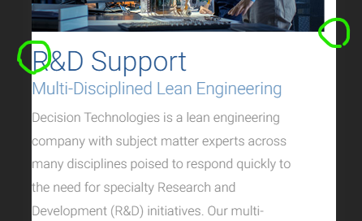

# Why Decision Tech - (/mk_category/why-decision-tech) – Mobile

* Problem: This page has the same margin inconsistencies as the “What We Do” page above.

# What We Help Accomplish – (/mk_category/what-we-help-accomplish) – Mobile

* Problem: This page has the same margin inconsistencies as the “What We Do” page above.

# Job Seekers – (/job-seekers) – Mobile

* Problem: The job title gets cut off and there is no horizontal scroll. The same is true when the user clicks on a specific position to view the listing (shown on right).

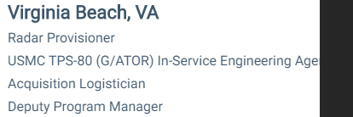 

* Problem: Table on job position page gets overlapped with other text, creating readability issues.

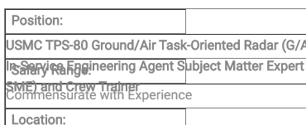

# 404 Error Page – (any bad link) – Desktop

* Problem: Any bad link within the site should present a “Page Not Found” message. Instead, it directs to a non-existent blog.

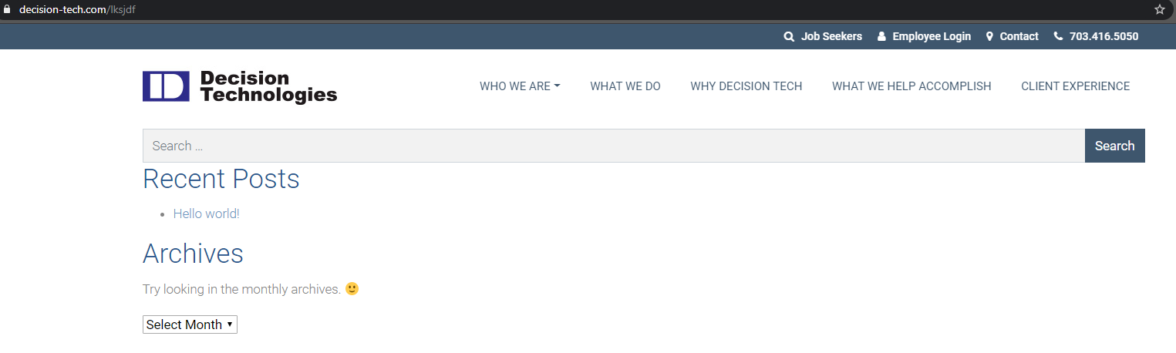

# Contact Us – (/contact-us) - Desktop

* Problem: Three of the markers on the map are labeled as the street address: 448 Viking Dr, 80 M St SE, 1569 Diamond Springs Rd.

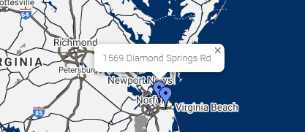

# Contact Us – (/contact-us) - Mobile

* Problem: The map loads showing the middle of the country with none of the markers visible.

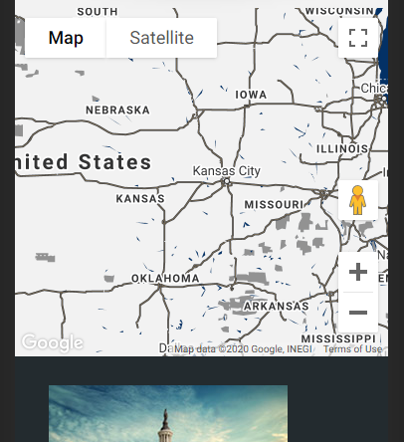

# Join Our Team – (/join-our-team) – Desktop

* Problem: Logo section has inaccurate title “Logo Strip Title”



# Terms of Use – (/terms-of-use) – Desktop

* Not sure if this is a problem: “headquarters in Miami, Florida”?

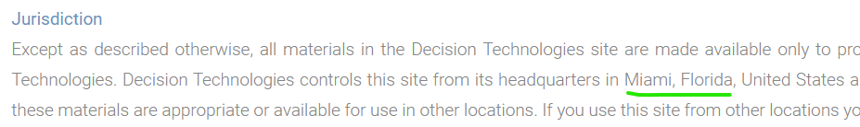

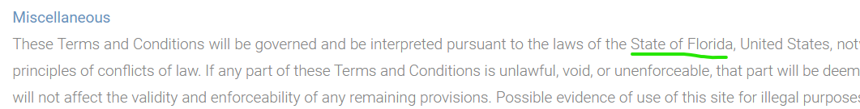

# Privacy Policy – (/privacy-policy) – Desktop

* Problem: Email address is inaccurate.

